**1)SIGN UP:**

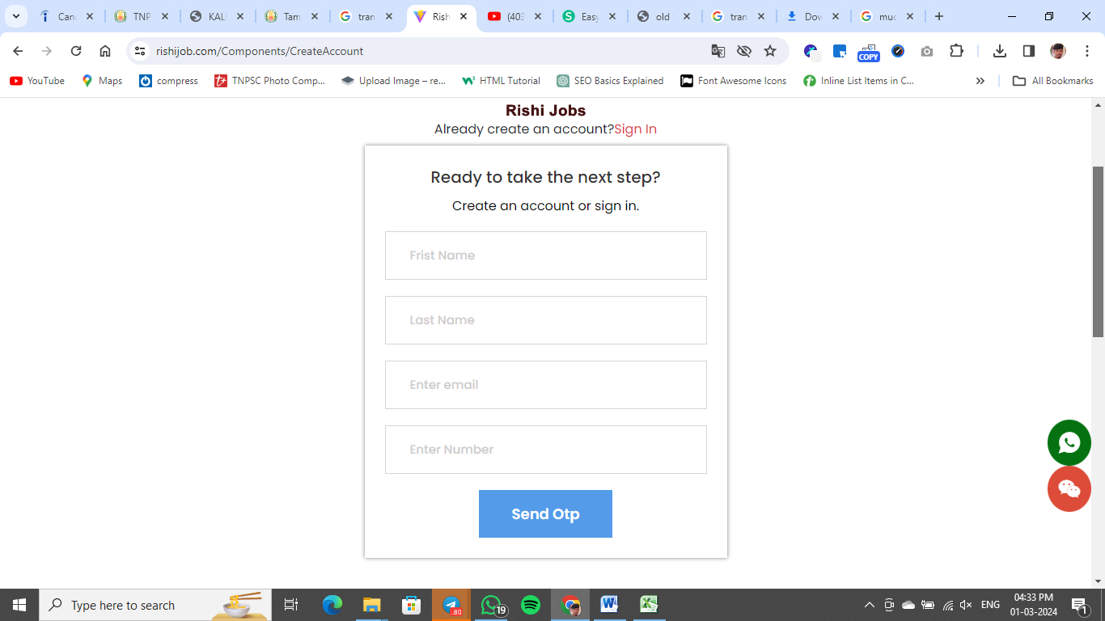

**output:**

|  |
| --- |
| **NAME** |
| **EMAIL** |
| **MOBILE NO** |
| **PASSWORD** |

**COMPLETE LOGIN AFTER POPUP “REGISTER SUCCESSFUL”.**

**2)SIGN IN:**

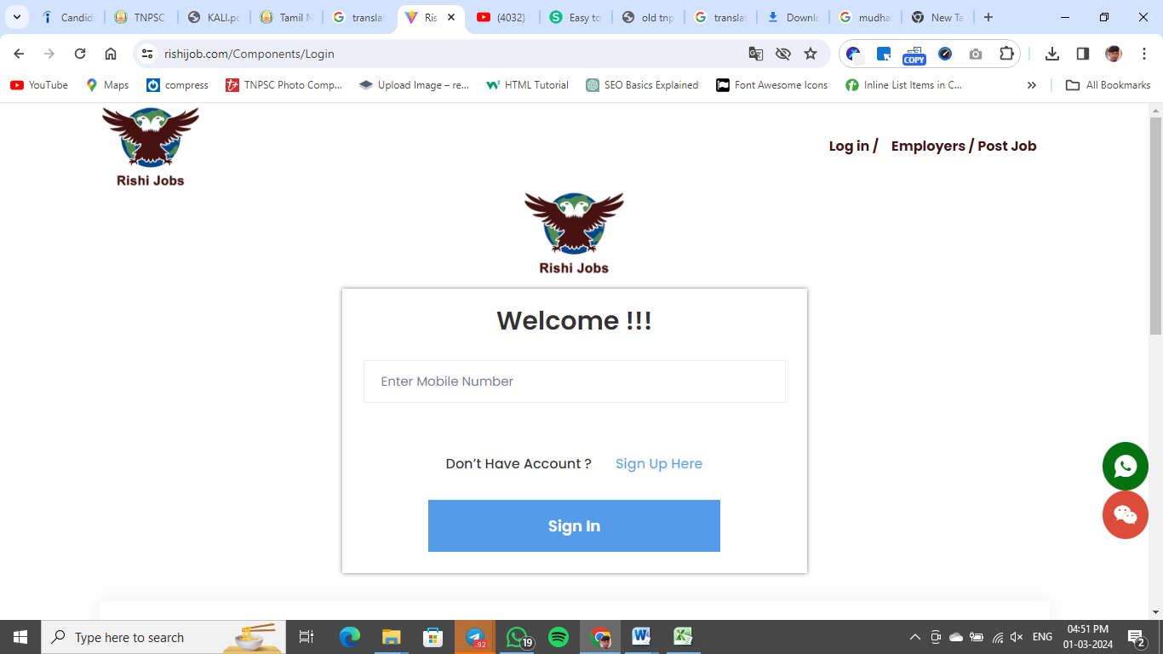

**output:**

|  |  |  |
| --- | --- | --- |
| |  | | --- | | **User name(mobile num)** |  |  | | --- | | **password** | |
| Forget password?   |  | | --- | | **Sign in** | |

**Note:**

* **Forget password required to mail id**
* **Sign in next page go to dashboard**
* **Show the dashboard popup message complete your profile.**

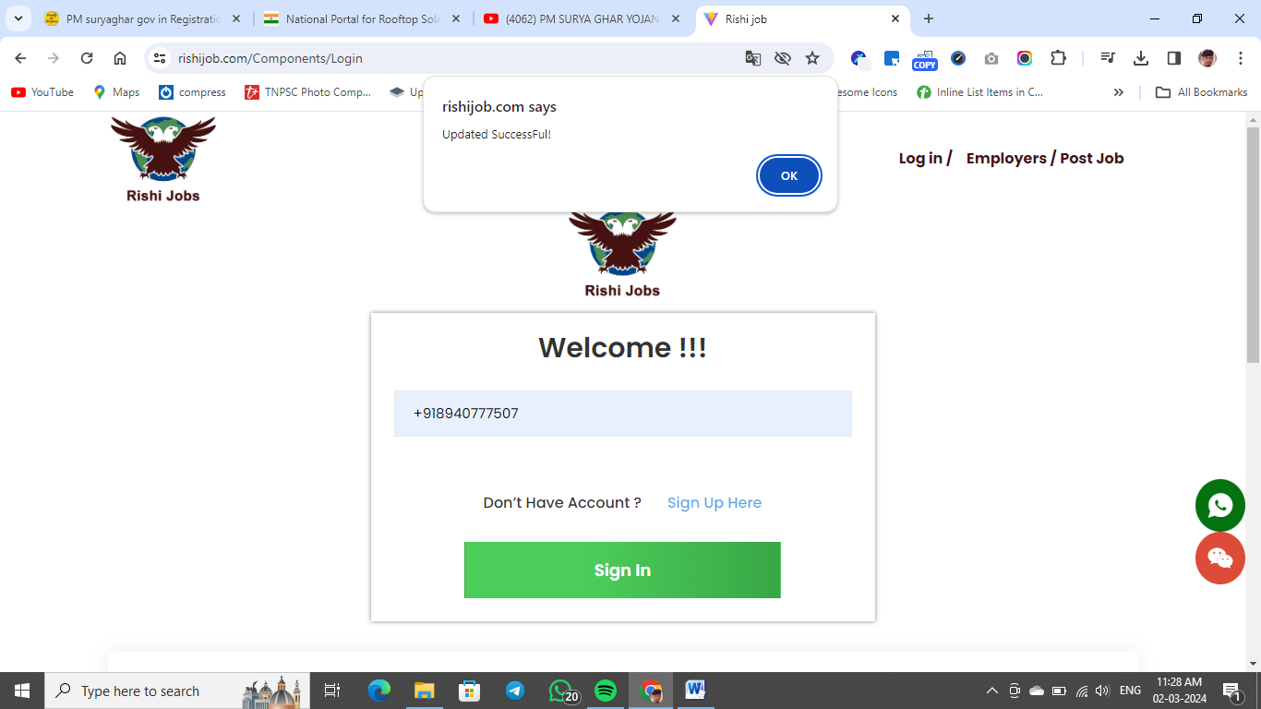

**User name not visible:**

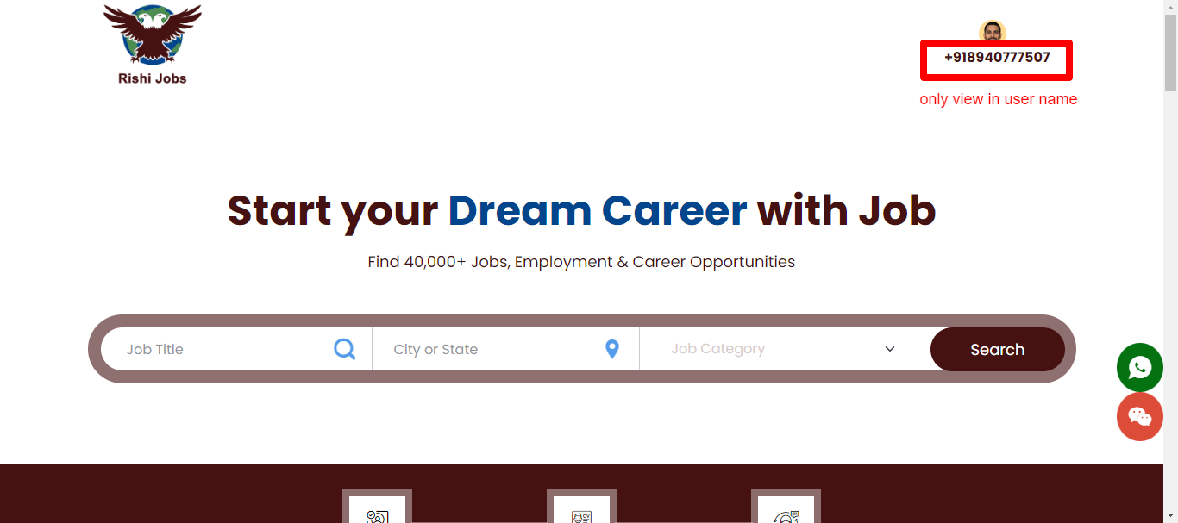

**Employees login:**

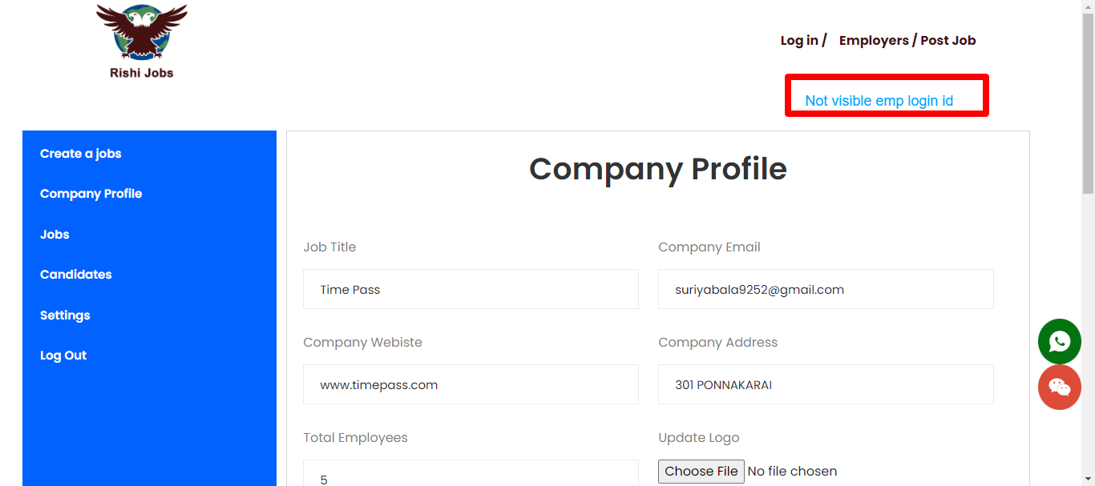

**Create job:**

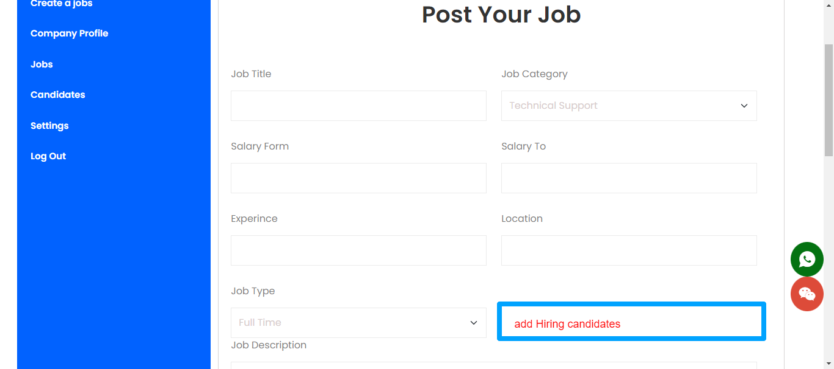

**Auto showing hiring candidates:**

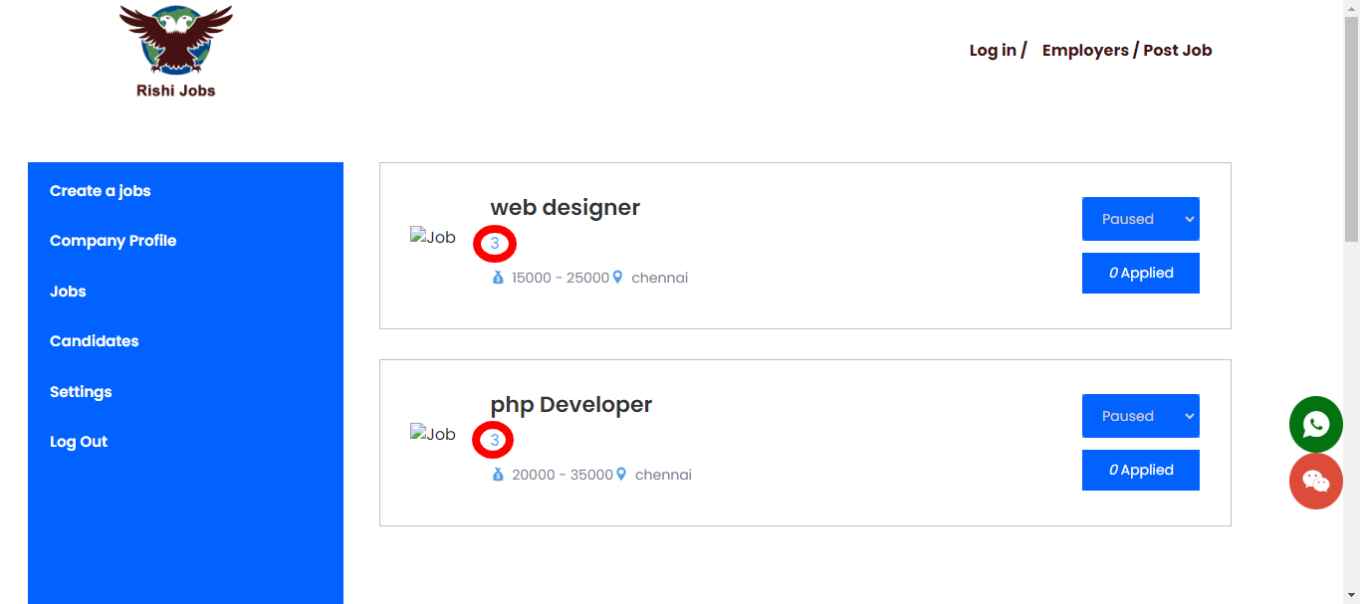

**Save jobs:**

**Not working**

**Not add to save jobs**

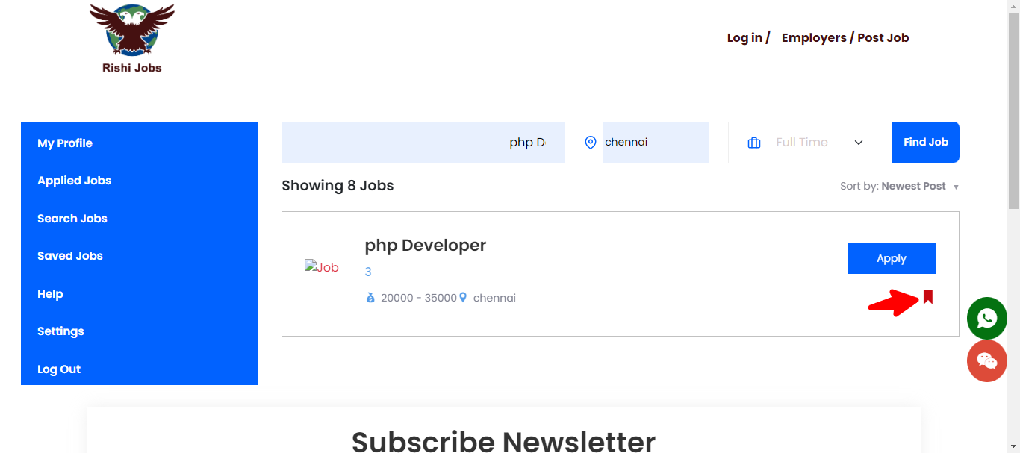

**Home page:**

**This link not working**

